**PROBLEM STATEMENT:**

*The problem statement of the project is:*

*Develop a browser-based application to demonstrate application of Face Recognition technology in the area of tracking the attendance.*

* Problems that are faced by the students and the faculty to track the attendance of the students for the particular period.
* The Main motive of the project to manage the attendance of every student.

**Project title:**

**FACE RECOGNITION BASED ATTENDANCE MANAGEMENT SYSTEM**

Project aim:

* **The aim of the project is to track the attendance of the student using a browser-based application which is face recognition application***.*

OBJECTIVES:

* It reduces/saves the time of the student and faculty for taking the attendance.
* As it is a face recognition-based attendance system there is reduced chances for fake attendance.
* It will not mark the attendance if the student is late to class.
* All the student details and the attendance of the students to the particular system is stored in a csv file and the database connected.
* The faculty can easily track the attendance of the student by checking the database.
* Encouraging the use of technology in daily lives.

PROJECT SPECIFICATIONS:

* Uses Haar Cascade algorithm for face detection.
* Requires good lighting condition for better camera capture capability
* Attendance is stored in a .csv file and can be digitally distributed and maintained.
* Requires XAMPP Control Panel to host the API.
* And requires localhost\phpMyAdmin to track the database of the attendance
* 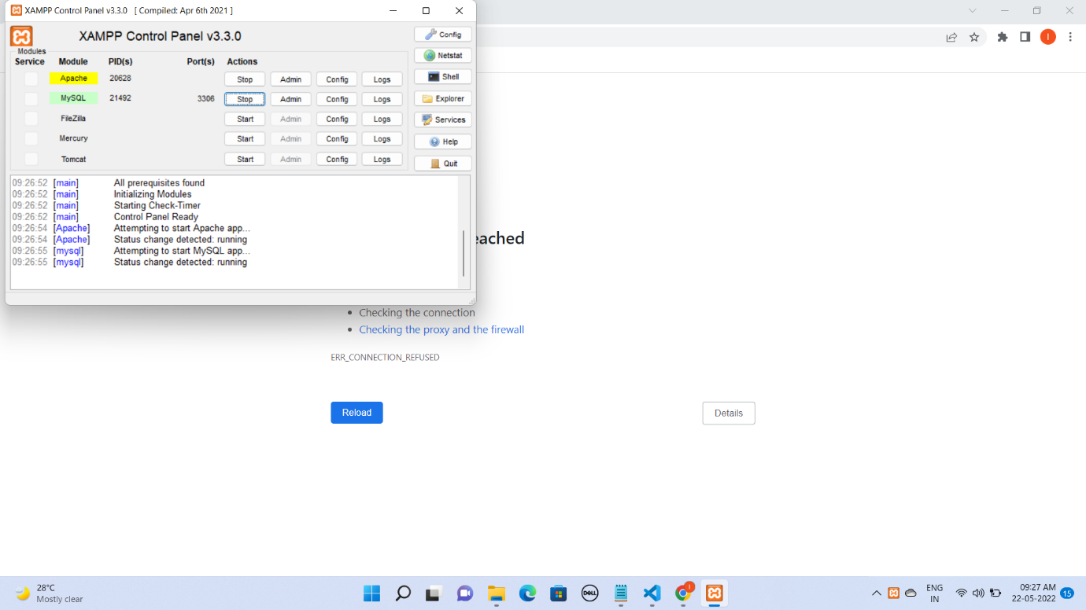

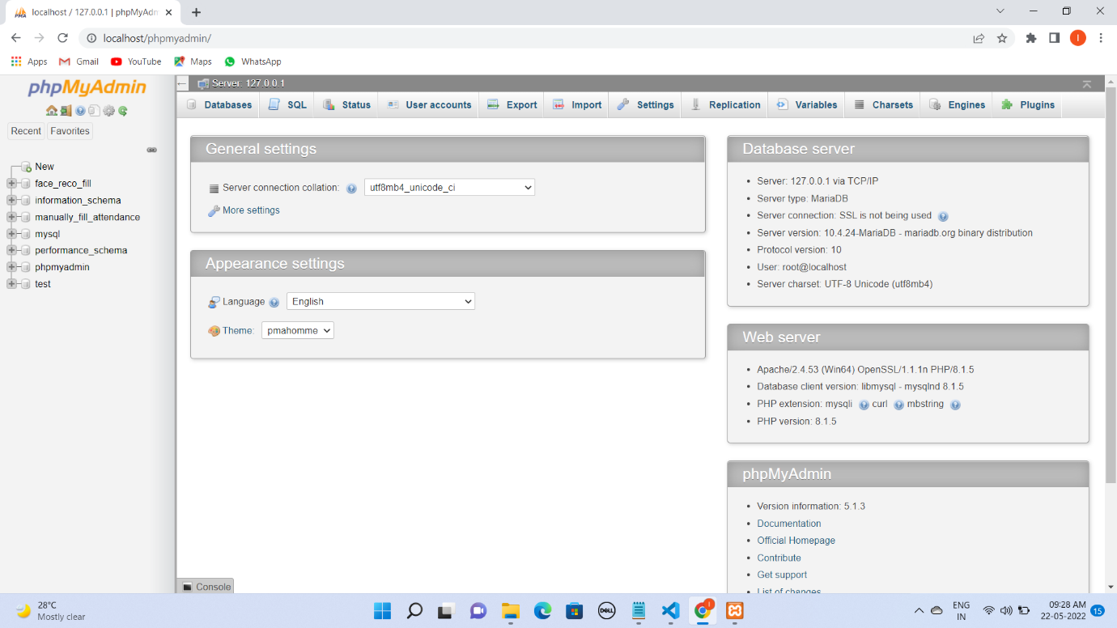

* In the local host there must be a database called face_reco_fill and manually_fill_attendance so create them.
* As it is a browser-based application it requires internet.
* You must create a “TrainingImage” folder in the system.

Fig: Functional Diagram

If match found stores in database if not shows unknown

Find Match in the database

Update Attendance Sheet .csv

GENERATE THE PIXELS OF THE TRAINED IMAGE

PIXELS ARE STORED THE PYTHON SHELL



VISION AQCUSITION

WEB CAM

**CODE REQUIREMENTS**:

**\* Opencv (pip install opencv-python)**

**\* Tkinter (Available in python)**

**\* PIL (`pip install Pillow`)**

**\* Pandas (pip install pandas)**

**\* os (pip install os-sys)**

**make sure you have the pip latest version**

steps**:**

**1)create a 'TrainingImage' folder in a project.**

**2)open the python code file which is 'AMS_Run.py' and change all the paths with your system path**

**3)Then Run 'AMS_Run.py' file.**

**Project Structure:**

**\*After running the python file you are directed to a GUI in that you need to give your face to data to system so fill your ID and Name in the GUI then click on ‘Take Images’ button. In this process your different angles images are taken.**

**\*It will take 70 images of your face in different angles and it save the images in ‘TrainingImage’ folder.**

**\*After that you find a button ‘Train Image’ where you have to train your saved images once it get trained it will display the message as the model is trained.**

**\* After the models are trained successfully our main aim of the project starts that is offline “attendance management system”**

**\*So whenever the person is attending a class after clicking on the “Automatic attendance button” the webcam will open for particular time that is 10 min so all the trained models who attend to the particular class should attend in that 10 min after the completion of 10 min the webcam will be stopped.**

**\*After that it can attendance by your face using our trained model (model will be save in ‘TrainingImageLabel’)**

**\*It will create ‘.csv’ file of attendance according to time and subject.**

**\* You can store the data in database ( install wampserver),change the database name according to your in ‘AMS_Run.py”.**

**\*”Manually Fill Attendance button” in UI is for filling a manual attendance (without face recognition), it also create a ‘.csv’ and store in a database.**

**HOW TO OPEN AND RUN THE BROWSER:**

**The url for opening the browser :** [**http://localhost/**](http://localhost/)**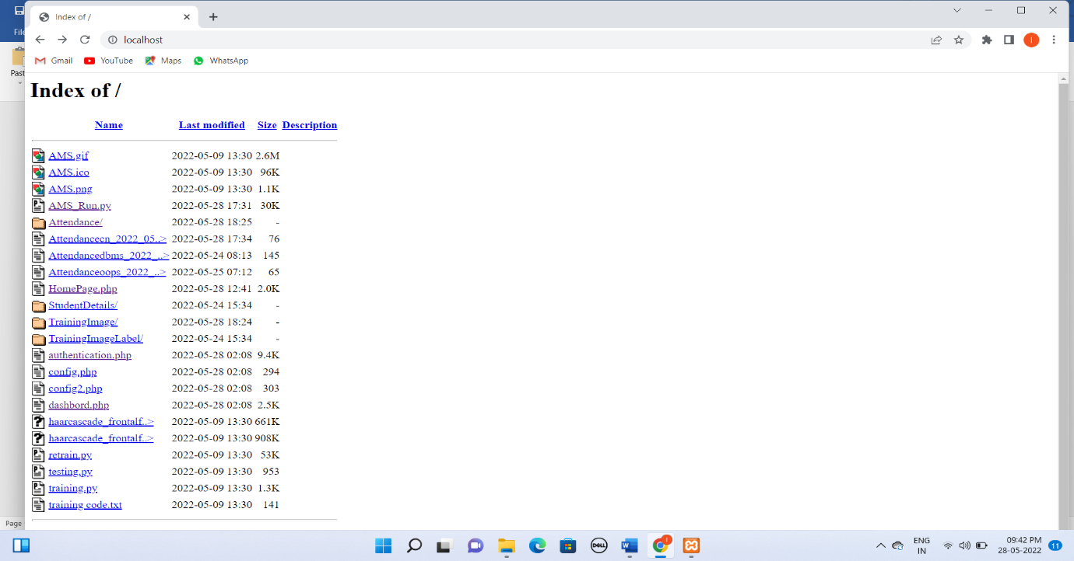 You will be directed to the browser where you find the Index page of the browser “Then click on HomePage.php” then you will be directed to the Homepage of the browser.**

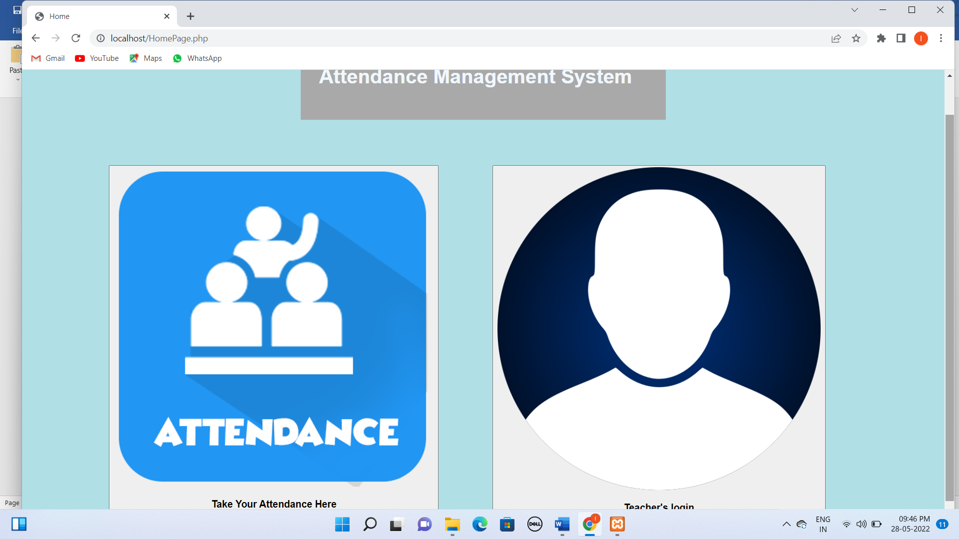

**The url for the Home Page is :** [**http://localhost/HomePage.php**](http://localhost/HomePage.php)

**There when you click on the attendance you our face recognition project will open.**





**\*) The Admin can access the students attendance by clicking on Teacher’s login and then by giving the username and password.**

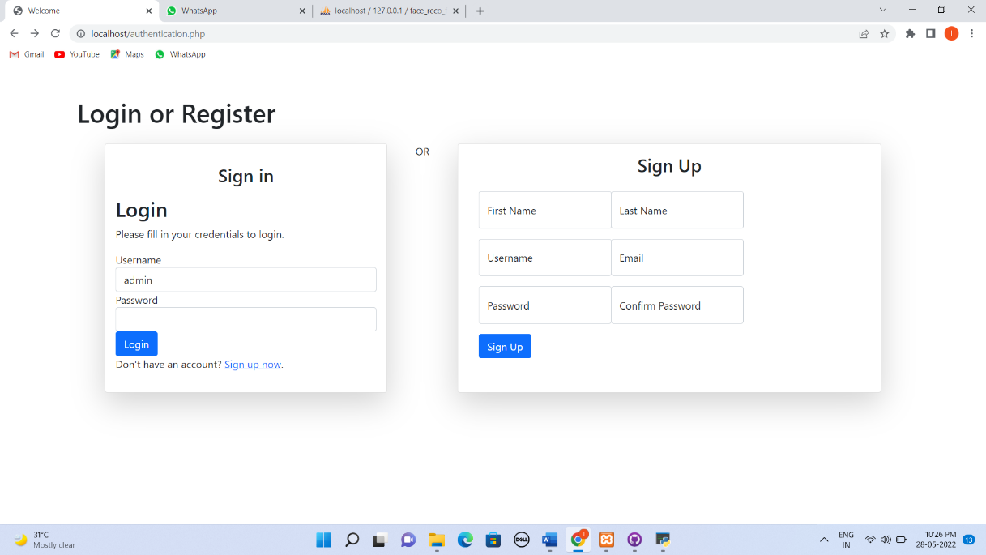

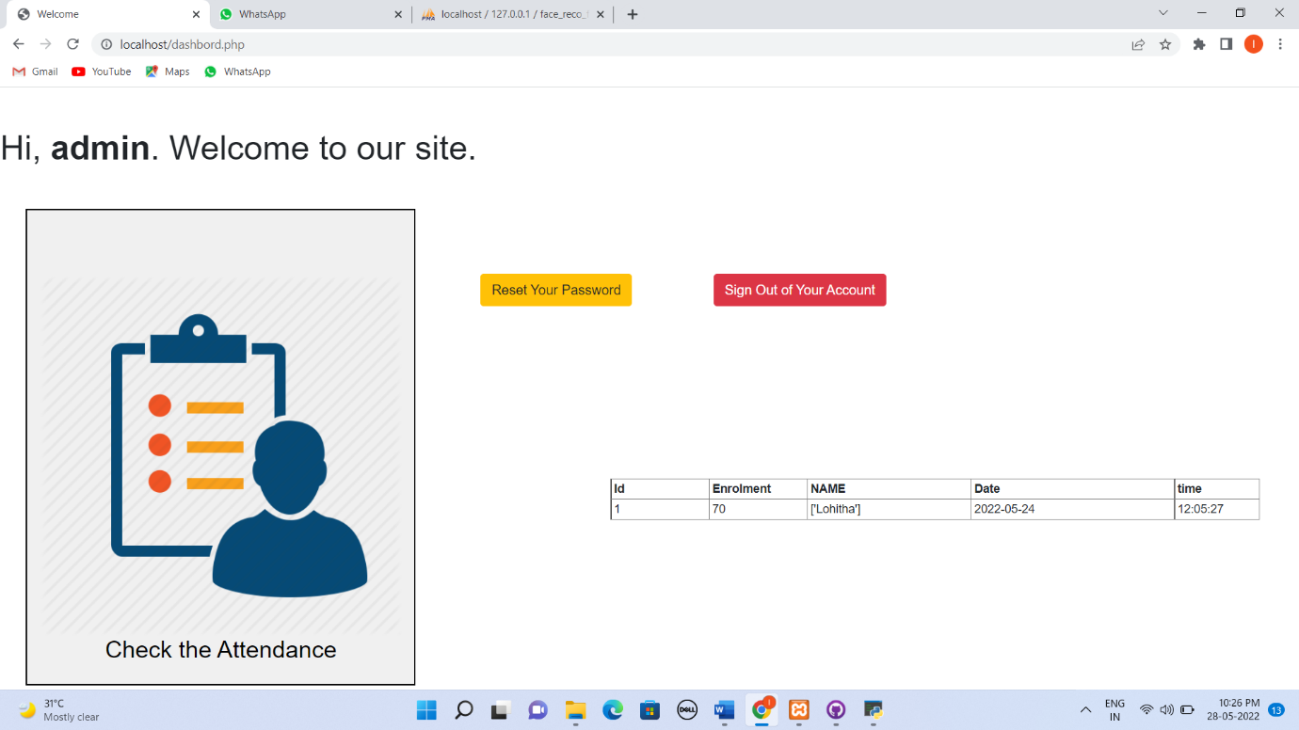

On clicking the check the attendance the admin can check the attendance.

USER INTERFACE IMAGE :

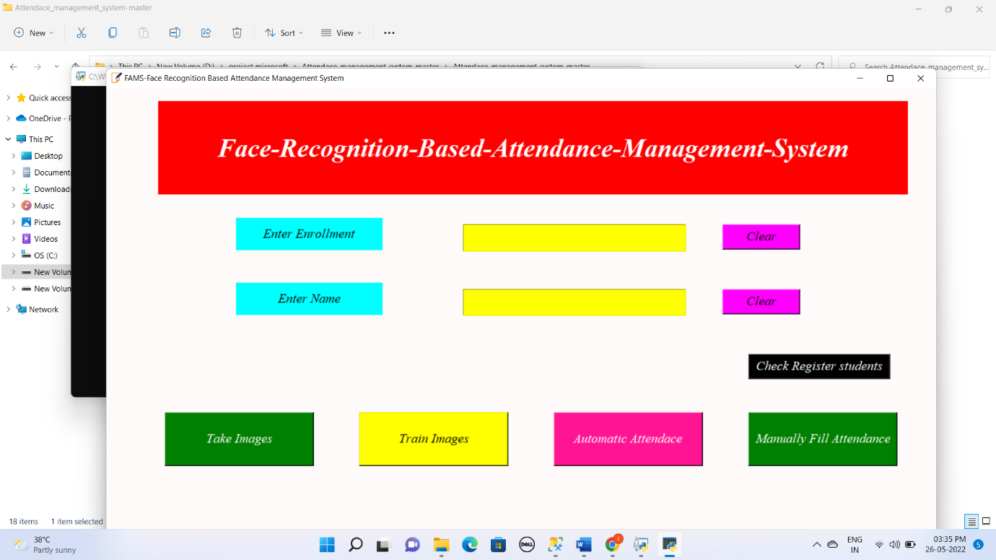

PROJECT WORKING:

This FACE RECOGNITION BASED ATTENDANCE SYSTEM is a browser based application where one must browse the url of the application after clicking on the url you are directed to the website where you find the user interface. In the user interface when you wish to fill the attendance for the first time click on the Take Image button where a webcam will open , it will take your images in different angles which is of a count 70.

Then you will be displayed with a message like Image is saved like below image.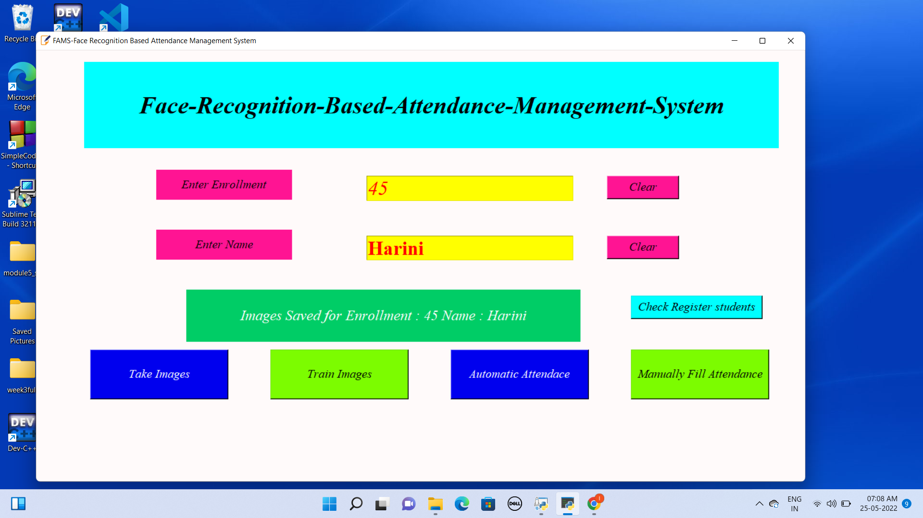



After the model is saved then click on the Train Images button where your saved model in the database is trained and you will receive a message as the “The Model is Trained” it is as shown below.

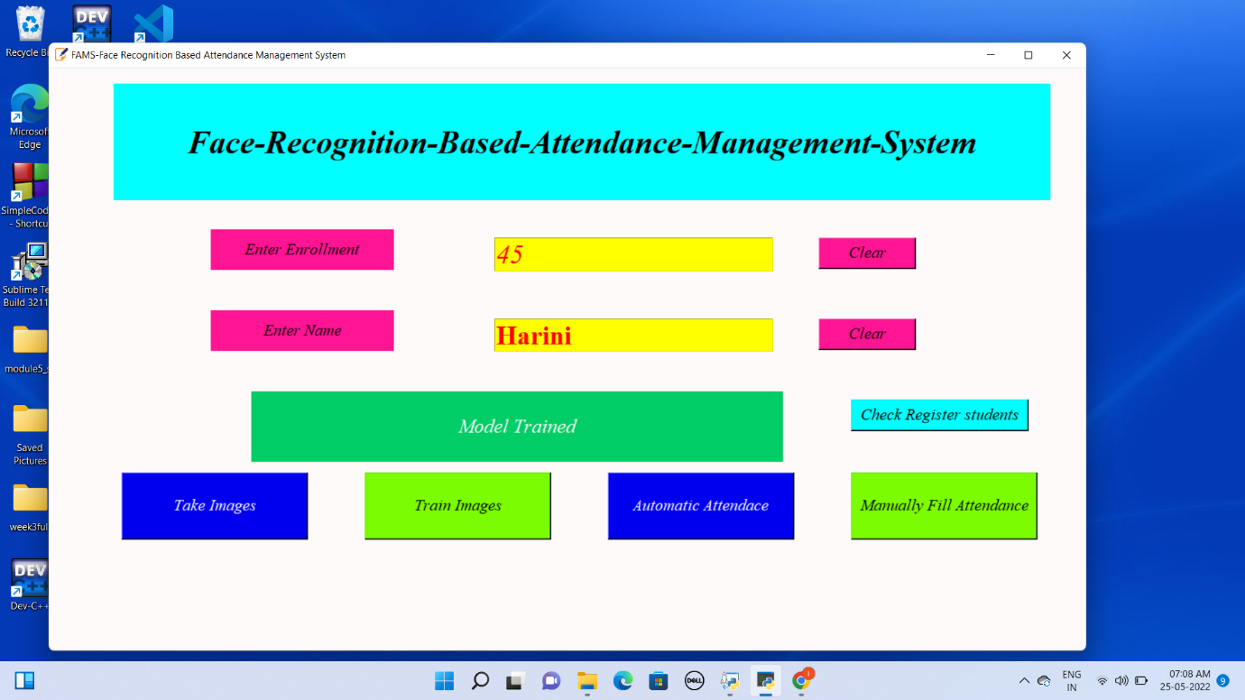

Now your model that is your face is trained and stored in the “TrainingImage” folder in backend.

Now our main motive of the project will start

**MOTIVE:**



**To take the attendance of the students who are present to the class in the period of 10 minutes.**

Whenever the students come for the attendance the click on the Automatic Attendance button, where you are directed to enter the subject you are attending to and click on fill attendance there again the webcam will open for 10 minutes, so the students should enter the class before 10 minutes after 10 minutes the webcam will closes and the details of the students who present before that 10 minutes will be marked as present and the details are stored in the database and a .csv file is generated.

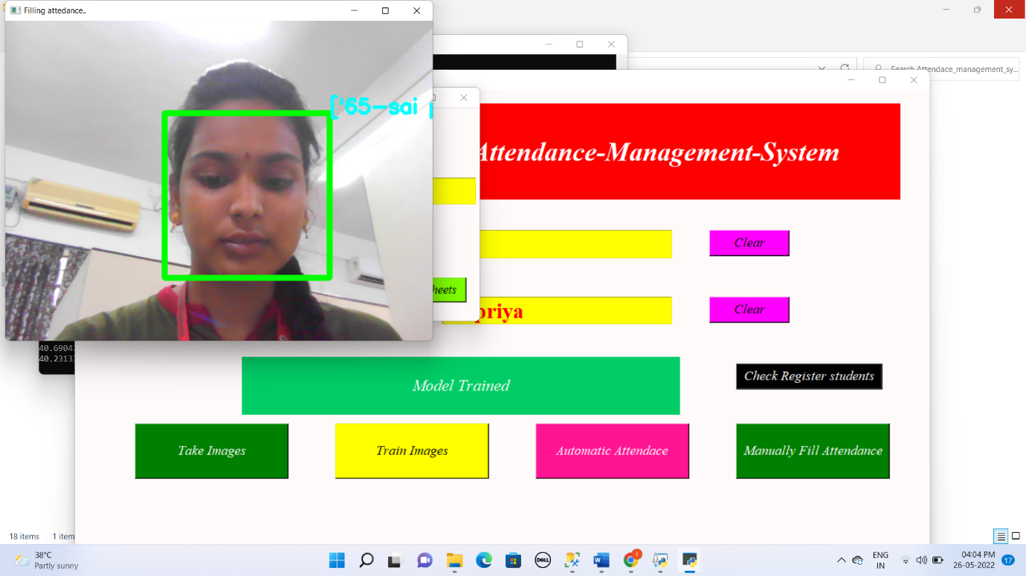

**FEATURES**:

1. The Admin can check the register students who completed to save their images by clicking on “CHECK REGISTER STUDENTS”
2. After clicking he must enter the username and password and press Login then he will get the table which contains the details of the registered stud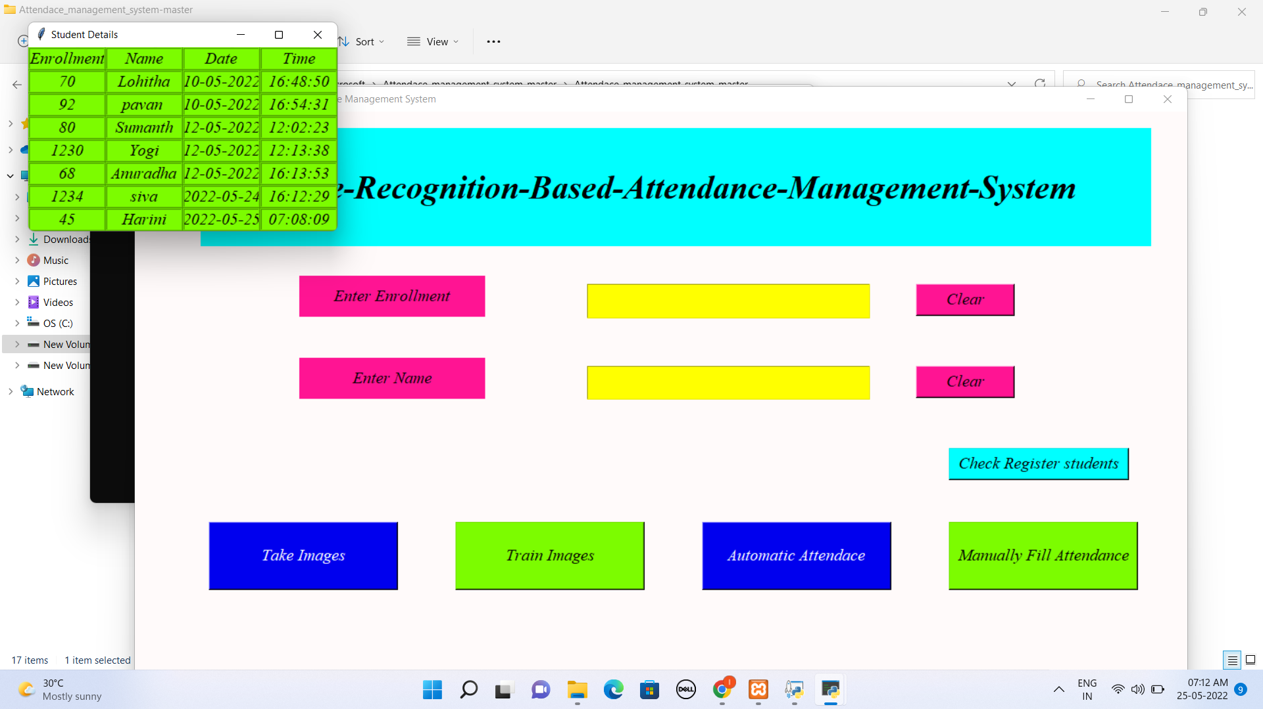

3)The students can also have a option to fill the attendance manually by clicking on manually fill attendance “it is used as an alternative if the face recognition is not working properly”.

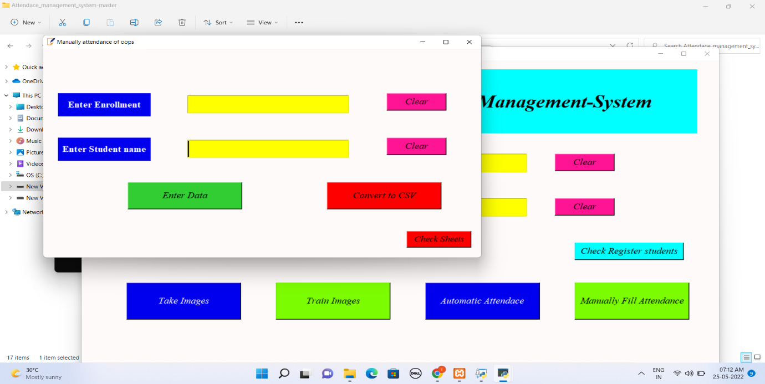

The student must enter there Enrollment and Name and click on the button Enter Data. Then they must click on the button convert to csv so the details of the student with their corresponding period for attendance is stored in the csv file. The corresponding .csv file looks like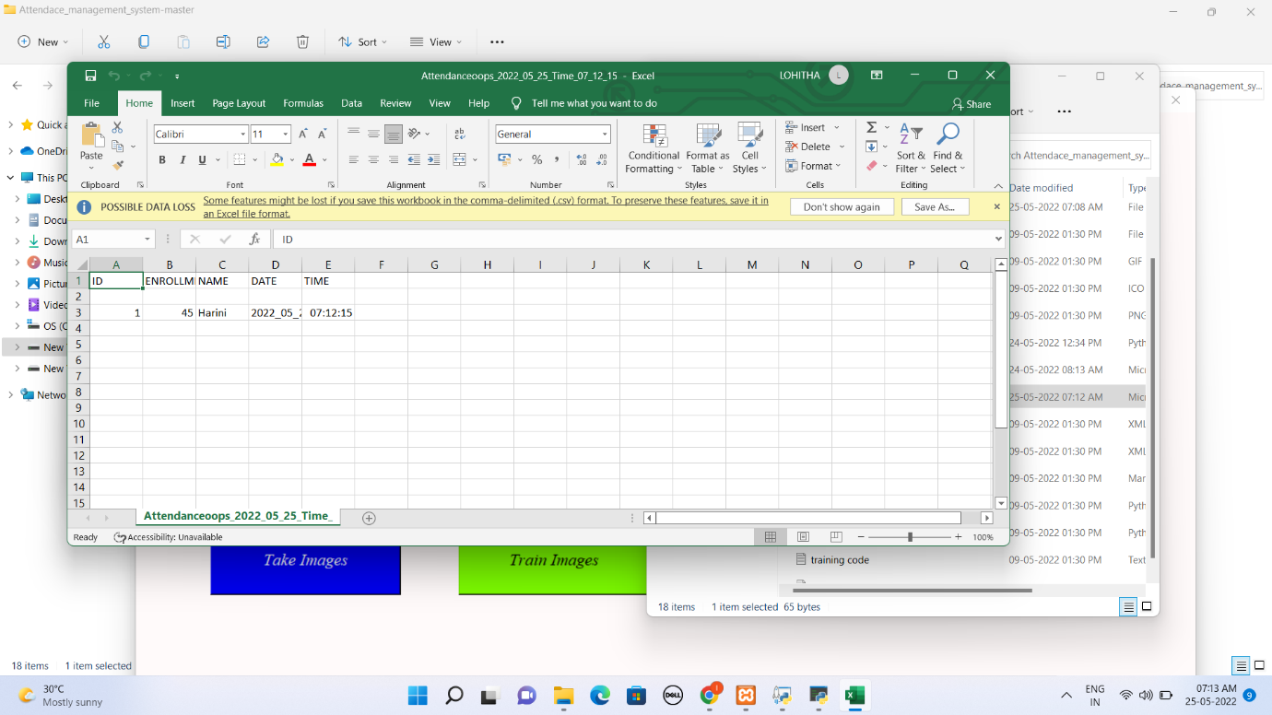

4)At last all the details of the student is stored in the localhost/phpMyAdmin

